Snorkeling 101: The Complete Guide To Snorkeling (Part I)
by Thomas Grønfeldt Senger | 1 comment
Grab your fins and mask, Let's go Snorkeling! - Yuri Arcurs
Get your fins on and mask ready!
Here's our guide to getting the most out of your snorkeling.
Snorkeling is often an underrated activity. For many travelers in tropic destinations, it's presented as something anyone can do, and often involves plowing through the surface with rental gear and a swim vest on. But snorkeling can be so much more!
In fact, modern scuba diving grew out of snorkeling, or skin diving as it was known then.
Snorkeling can be a very rewarding activity. It benefits from its simplicity, where you can simply grab a mask and some fins, rather than hauling a bag full of heavy dive gear. This also allows for more flexibility, allowing you to bring your gear on trips where bringing tons of scuba gear isn’t a possibility. And the lack of bubbles means you can often get closer to marine wildlife than with scuba gear on.
Learn The Differences Between Snorkeling, Free and Skin Diving
In this guide, we’ll cover the three aspects that are necessary to getting the most out of your snorkeling.
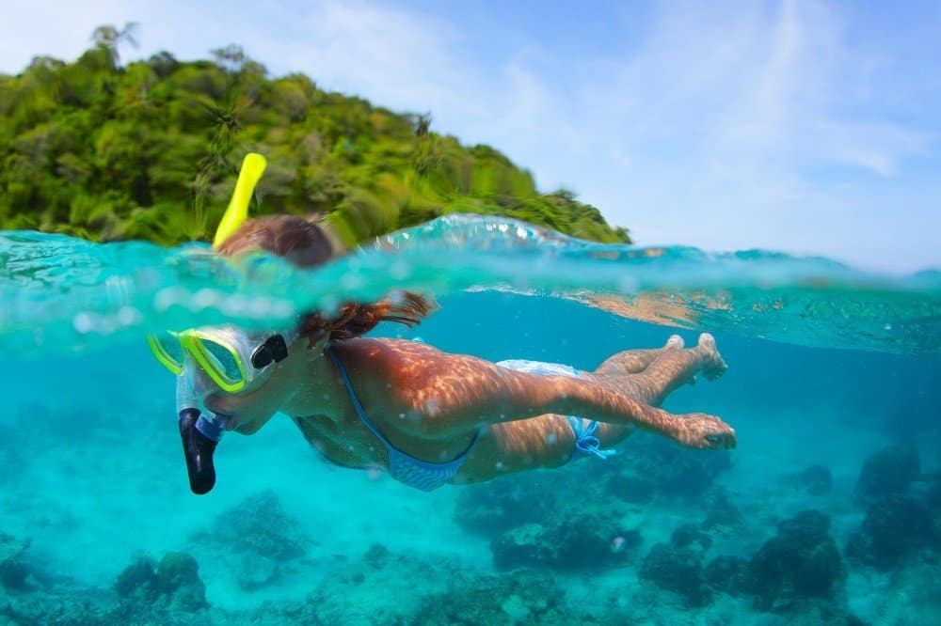
You will experience a wonderful world through snorkeling - Credit: Dudarev Mikhail

Preparation
To really make the most of your next snorkeling trip, and leave the newbies in your wake, a bit of preparation is helpful.

Improve your swimming
If your swimming skills aren’t the best, take some swimming lessons at your local pool. And even if you’re a decent swimmer, becoming an even better swimmer will only benefit you in the water.
Focus in particular on the freestyle, as the kicking technique from that style is the one you’ll be using when snorkeling.
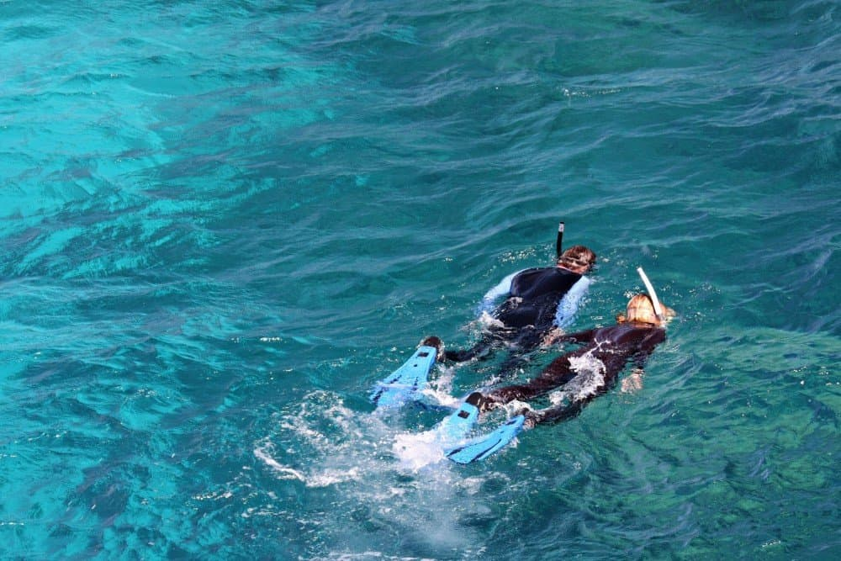
Remember to stretch your legs when swimming with fins - Credit: Neale Cousland
Improving your strength and endurance in the muscles engaged by the kick will help you snorkel more, and with less effort, leaving you free to enjoy the environment instead.
Being a strong swimmer will also allow you to ditch the swim vest that are often popular with snorkeling outfits.
While a snorkeling vest helps you with flotation, it will also hinder your movements in the water. And make it harder, if not impossible, to do dives to check out a reef or fish.
Good swimming skills will help keep you safe in the water.

Practice
Swimming is one thing - Swimming with fins on is something else entirely.
The extra drag and weight of the fins put extra toll on the muscles, which is why you might experienced cramping up if you’re not used to swimming with fins.
So take a pair of fins to the local pool, or your home waters, and do laps with them on.
Learn The Finning Techniques used for Scuba Diving
Mix it up, so you do both long stretches at a mid-level pace, and shorter, faster stretches.

Improve your breath hold
Many snorkelers simply stay at the surface, and use the snorkel to breathe while looking down.
A number of more advanced snorkelers, though, move into skin diving territory by doing occasional dives below the surface while holding their breath.
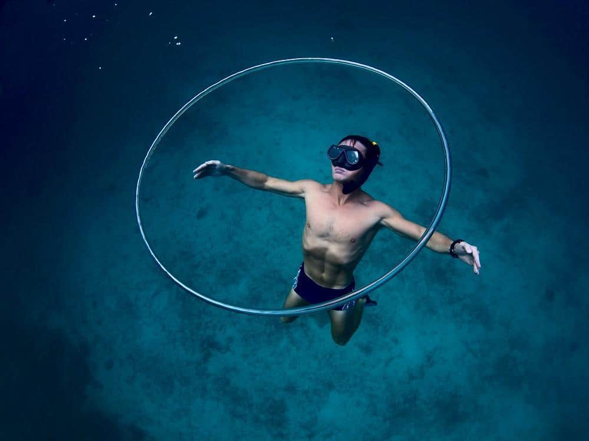
Deep breath, swim slow and focus - Credit: Dudarev Mikhail
This will allow you to get a much closer look of the marine wildlife, and you'll explore reefs and other underwater features up close.
To maximize your time underwater, you can train your breath holding capacity, as well as your swimming efficiency.
Read the Full Skin and Breath hold Free Diving Guide
For more experience hit up your local freediving club for hands on training and practice. With the growing popularity of freediving, these are becoming increasingly easy to find.
In the next article of this series, we’ll look at the gear you need for snorkeling & how you ca Fine tune your Snorkeling Skills.

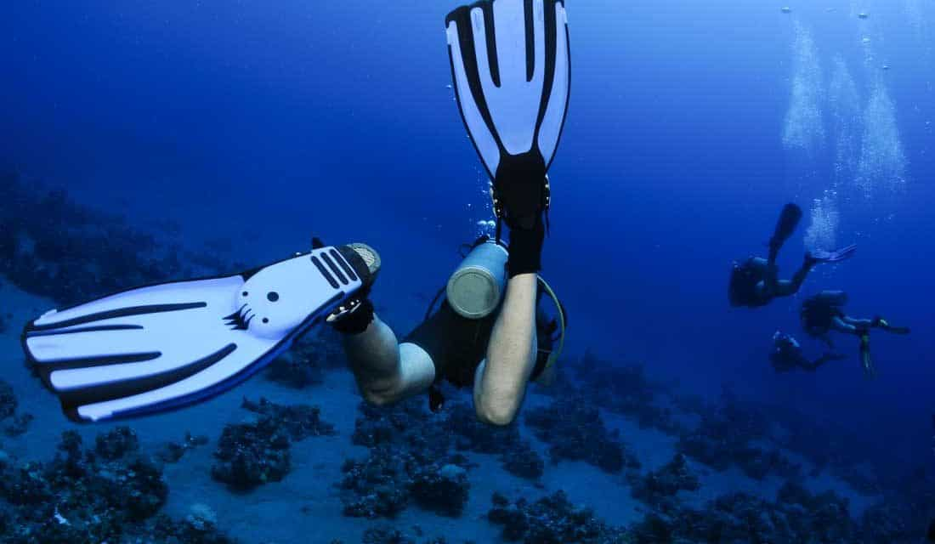

Finning Techniques – How To Get The Most Propulsion From Your Kick
by Thomas Grønfeldt Senger | 14 comments
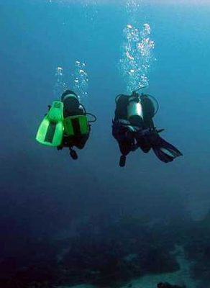
- Thomas Groenfeldt

Finning is the process of generating propulsion by moving our scuba fins.
In that sense, it is probably the most basic of skills in diving, and one that most of us are already able to do when we enter our first dive course.
For anyone who has spent any proportions of their childhood in and around water, it is as natural as walking or running.
Here's a Basic Guide On Choosing Scuba Fins.
But, like running, it is something that most of us might be able to do, but that doesn’t mean that we do it well, never mind optimally.
So like many runners experience a huge increase in running pleasure and efficiency, many divers could benefit from working on their finning techniques.

Choose The Right Kick For The Circumstances
Better finning technique, in particular choosing the right technique for the right circumstances, can increase the efficiency of your dive.
This, in turn, will decrease your air consumption and the physical fatigue you experience from a dive, extending your dives and increasing the pleasure of them.
Also, picking the right finning technique can decrease the level of environmental disturbance you generate. The right finning technique can mean less silt kicked up when diving in a cave or close to a silty bottom, which can, in worst case scenario, be a matter of life and death, as the case of cave diving accident in Italy’s Grotta Rossoproved all too well.
There are three main fin kicks that any diver should know. These are flutter kicks, frog kicks, and bent-knee cave diver kicks.
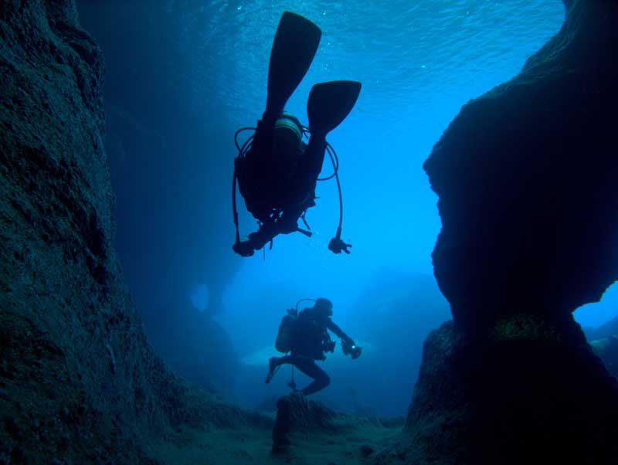
When in Rome, Kick as the Romans - Credit: Takashi Usui

Flutter kicks
The flutter kick is the basic finning technique that most divers use, this technique is similar to the leg part of freestyle swimming.
Watch 90 percent of all divers, and you’ll see them use flutter kicks. The technique was the only one taught until not that long ago, so any old dive movie (Jacques-Yves Cousteau’s films and the James Bond movie “Thunderball” to name a few), you’ll see this kick too.
The reason for its popularity is quite simply that it is the strongest of all the kicking techniques, and it generates a lot of propulsion. And back in the early days of diving, before the invention of the BCD, speed was the primary way of maintaining buoyancy.
The advantage of this kick is the forcefulness of it. It is great for moving at fairly high speed, or when fighting a current. The vertical up-down movement of the legs also means it is very useful for wall diving, especially when diving by a wall covered in corals. As there’s less risk of kicking the corals or the backwash of the finning destroying corals.
The disadvantages of this kick are related to the advantages. The forcefulness of the kick means that it is fairly strenuous, and increases air consumption because of it. Also, the vertical movement can kick up a lot of silt if you’re diving close to a loose bottom.
In open water, this is annoying, in particular for the divers following you, but in a cave, it can be downright dangerous. Also, the continuous movement can lead to using movement for buoyancy, rather than proper scuba technique.
Bottom line: Fast, powerful technique, good for when you’re fighting a current, for short bursts of speed, and for diving close to vertical structures.
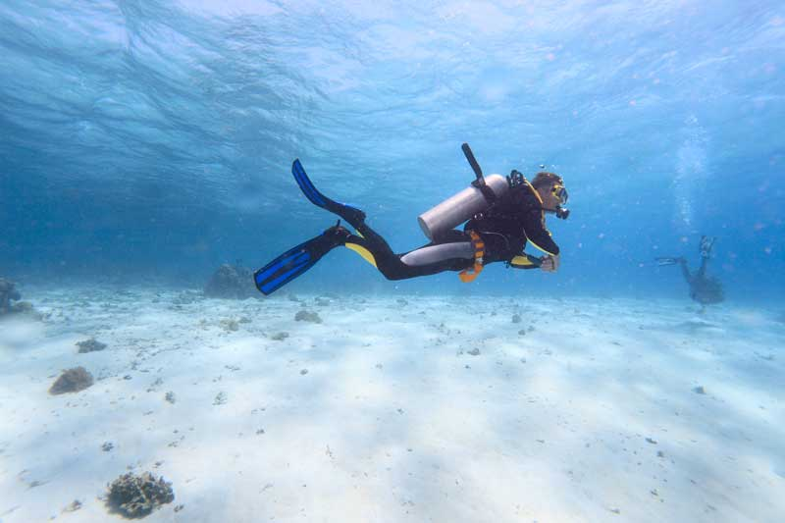
The "Fast and Furious' of all kicks is the flutter kick - Credit: Rostislav Ageev

Frog kick
The aptly named frog kick looks very similar to the leg portion of the breast stroke from swimming. A large and wide kick, that utilizes the full strength of the leg, it is a good, general technique for open-water diving, either in the water column, or close to the bottom. Because the movement and propulsion isn’t continuous, good buoyancy technique is required, though.
The movement here is horizontal, or close to it, meaning that when swimming close to the bottom, there is minimal disturbance of the bottom, which in turn will maintain the visibility for any divers that come after you. However, the width of the kick means that the kick isn’t recommended for caves, or when diving close to a wall.
This kick, combined with good buoyancy, will quickly become your go-to technique once you get used to it, and will likely decrease your air consumption quite significantly. The more properly trimmed your position in the water, and the more you take advantage of the gliding phase before initiating the next kick, the more you’ll reduce your energy (and air) consumption.
Bottom line: powerful kick, that can be extremely efficient, especially if you master the kick-and-glide aspect. Good for open-water diving in mild currents, in the water column or close to the bottom. Not advisable in stronger currents or close to walls.

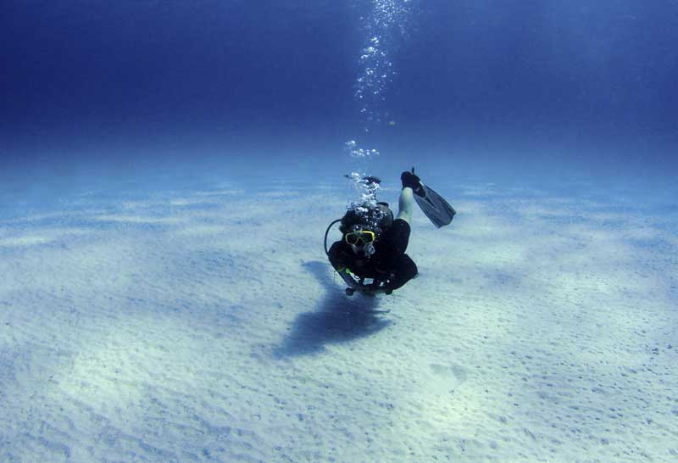
The cleverly named frog kick is suitable when close to the bottom - Credit: DJ Mattaar

Bent-Knee Cave Diver Kick
This technique with the complicated name is the go-to technique for technical divers, and is the one that causes the least disturbance of the environment.
The bent knees means that the movement is very limited, with the entire kick coming only from a small movement in the hips, combined with a kick of the ankles. This means that propulsion is limited, compared to the two kicks above, but it also decreases strain and air consumption.
The small movement means that it works well in cramped areas, such as inside wrecks and caves, and when executed properly, can minimize the amount of silt kicked up to almost nothing.
Here's a very compelling guide on How To Survive A Silt-Out!.
For this reason, it is also the recommended technique for diving close a very silty bottom.
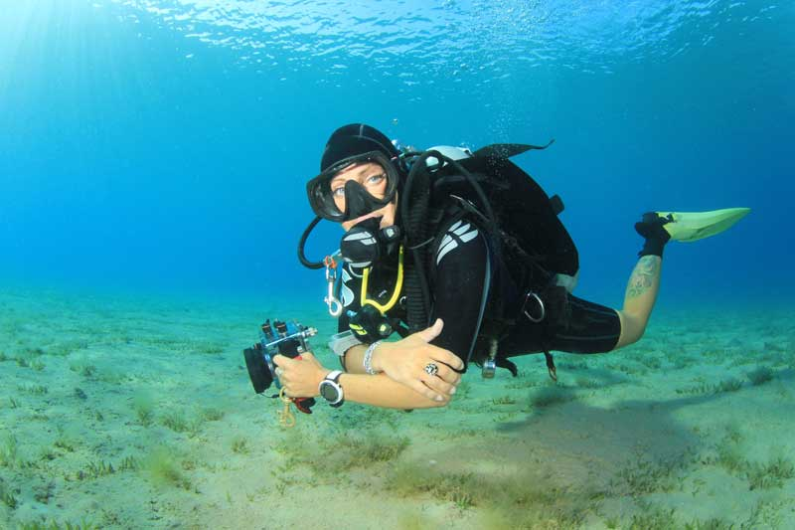
Bent-knee cave diver kick may be stealth-like but helps avoid a silt-out - Credit: Rich Carey
The slow movement also means that this technique helps you slow down, making it good for muck dives or other nature dives where you’ll be looking for small animal life.
Because it is a very low-propulsion kick, this technique has its limitation when swimming against a current, though.
Bottom line: a minimal-impact kick, that is ideal for cramped environments and close to very silty bottoms, as well as helping you slow down during your dives and maximize your available air.

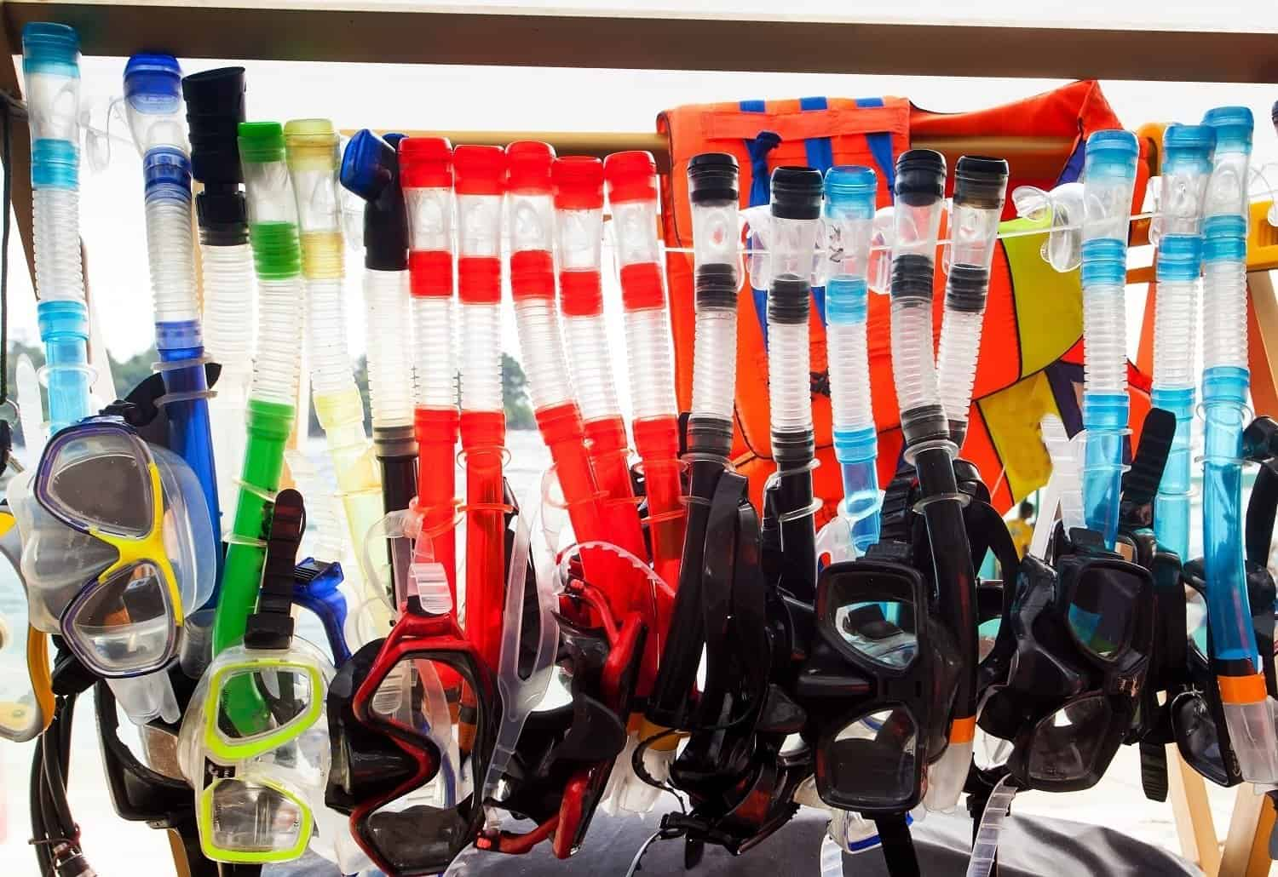

Snorkeling Equipment: The Complete Guide To Snorkeling (Part II)
by Thomas Grønfeldt Senger | 0 comments
Always try your snorkel gear first - Milkovasa
Do you Love snorkeling?
Here’s everything you need to know about snorkeling gear.
Get your flippers on with our guide to getting the most from your snorkeling
Read guide: Covering the Basics of Snorkeling
In this second installment we’ll look at equipment for snorkeling.
We often think of snorkeling as an equipment-light kind of activity, and often just rent or borrow gear when we go snorkeling. Still there are numerous advantages to having our own, or at least have an idea of what we like when we’re presented with selecting gear from a big box on the boat or dive shop.

The Basic Snorkeling Equipment
Snorkeling doesn’t require much gear, compared to scuba diving. But the lower amount of gear doesn’t make selecting that gear any less important.
Also read: What To Look For When Buying a Mask
The basics of snorkeling are a mask, fins, a snorkel, and possibly some exposure protection.
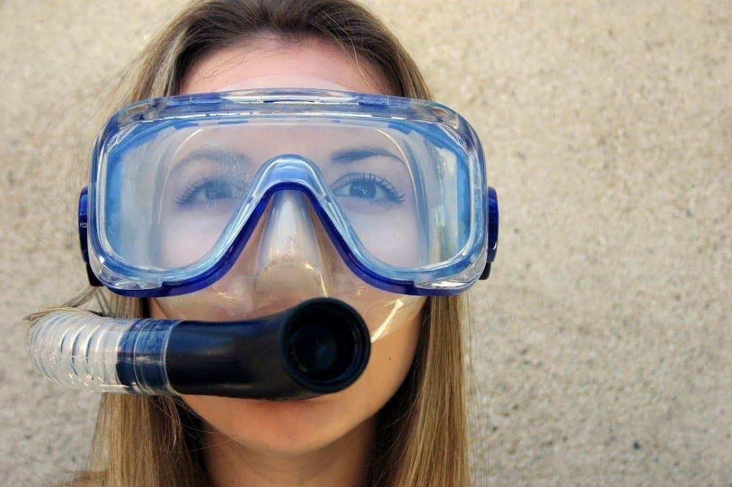
The Basics of Snorkel Equipment - Jason Stitt

What to Look For When Choosing a Snorkeling Mask
The mask allows to see underwater, and seeing as we’re snorkeling to experience the underwater world, this is of course critical.

Mask construction
Make sure your mask of choice is a “real” diving or snorkeling mask. By this I mean that it should be made for the purpose of diving or snorkeling, rather than a cheap mask bought in a supermarket.
Properly constructed masks will feature shatterproof glass, and are made so they can withstand pressure if you go for breath-hold dives.
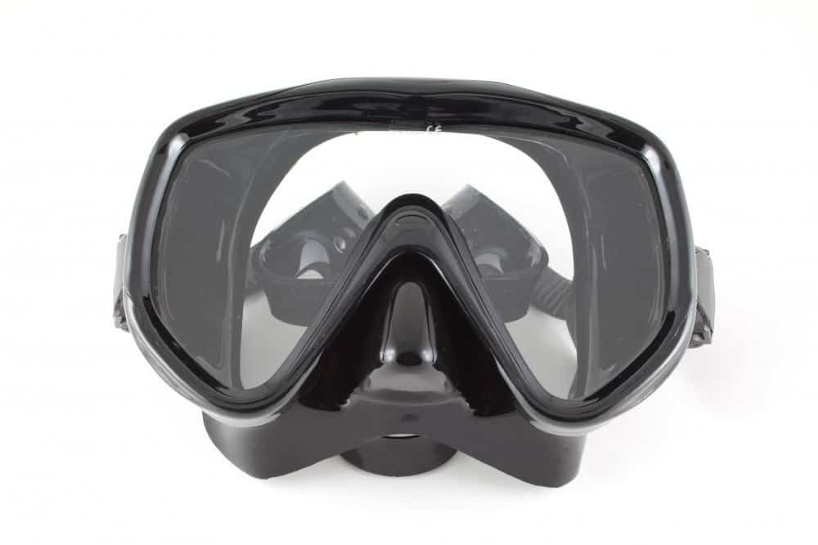
Choose a mask design you like and that fits your face - FomaA

How should the Mask be designed
When choosing a mask, pick one with a relatively small volume, meaning that the air space trapped inside the mask isn’t larger than necessary.
This will make it easier to clear if water should come in, and makes it easier to equalize it if you dive below the surface.
What’s the difference Between Snorkeling, Free Diving and Skin Diving?
Go for one with a good field of vision. I prefer mono-glass masks, meaning that the mask is made up with one large piece of class, rather than two pieces, one for each eye, but this is a matter of personal taste.

How to check if the Mask fit
The fit of the mask is crucial, but can be done in a few easy steps:
- Put the mask on without putting the strap around your head
- Inhale lightly through your nose
- Let the mask go
If the mask sticks to your face simply from the vacuum you create by inhaling, it has a reasonably good fit.
Put the mask strap on and exhale from your nose. You should be able to force the exhaled air out under the mask skirt without too much effort. Otherwise, emptying the mask if water comes in will be difficult.
Wear the mask for a few minutes and make note of anywhere the mask puts uncomfortable pressure on your face.
Typical places are the underside of the tip of the nose, between the eyes and on the forehead. If all of these are comfortable, you’re well on your way to finding a good mask.
Learn How to Defog a Mask
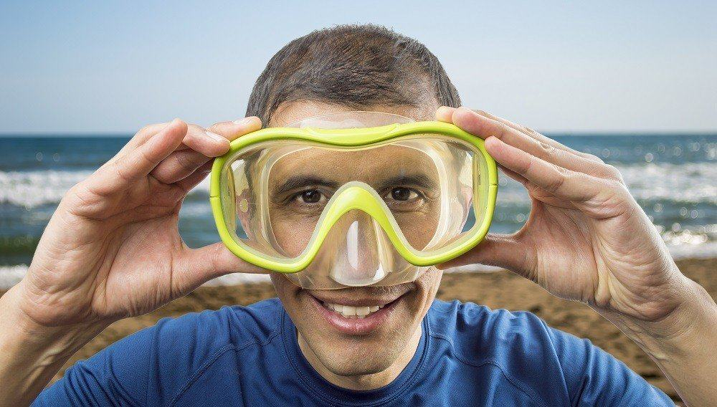
Mask on, inhale with nose, let go - if it stays it's a fit - Cunaplus

Choosing Fins for Snorkeling
Most people snorkel in warm water, so full-heel fins are the better choice here.
Learn the difference between Scuba and Snorkeling fins
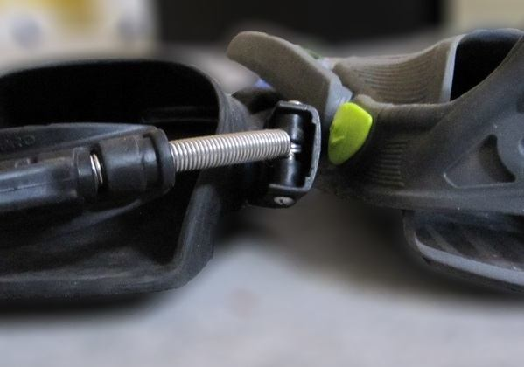
Openheal made for scuba and snorkeling - Torben Lonne @ DIVE.in
If you’ll be snorkeling in cold water, where you’ll be wearing booties, an open-heel fin is a better choice.
Go for a fin with a reasonable amount of flex, but stiffer around the foot.
Comfort is key, so try some on.
If you intend to do basic snorkeling, sticking to the surface, and will be travelling with them, you may want to consider a shorter fin, which is easier to pack. If you’ll be doing breath-hold diving, consider a traditional freediving, which tend to be longer and give more thrust in relation to energy used.
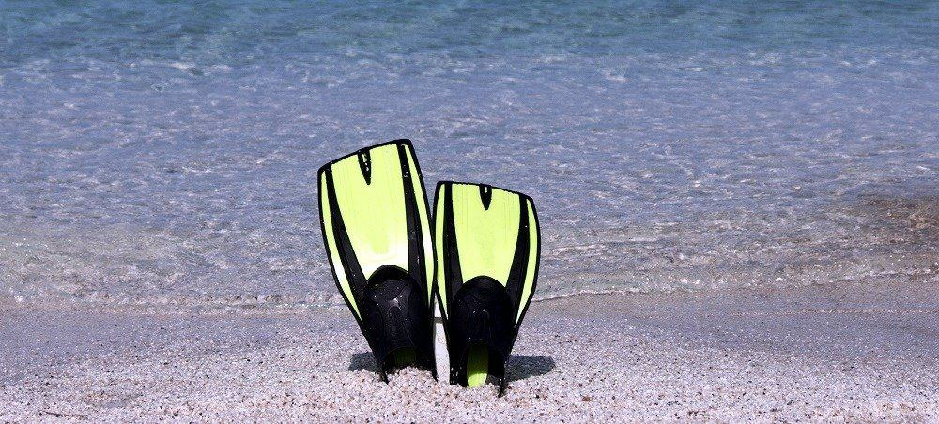
Go for fit over color and type - Atm2003

Choosing the Right Snorkel
A snorkel is a fairly basic piece of equipment. Go for one that isn’t too long, as the longer the snorkel is, the harder it is to breathe in.
A good, medium length will work well in making breathing easy while being elevated enough to keep it out of the water.
A variety of oneway-filters are used to prevent water from entering the snorkel, and these can be a benefit for snorkeling in choppy water, or for people looking to do breath-hold dives.
Make sure your snorkel of choice can be somehow attached to your mask strap so you don’t drop it accidentally.

Choosing a Snorkeling Wetsuit
For tropical waters, “exposure protection” may simply be swimwear and lots of SPF50.
But a rash guard can be helpful for a bit of protection against the sun and a bit of warmth for extended snorkel trips.
For cooler waters a neoprene top (short-sleeved, sleeveless or full-sleeved as you prefer) can help keep you warm, and for even cooler waters, consider a wetsuit, either a shorty or a full-length.
Wetsuits: Why You Need To Buy Your Own
If you do wear any neoprene elements, do factor in the buoyancy of these, and if you chose to do any dives, consider adding a bit of weight on a weight belt to allow you to submerge. Err on the side of caution, though, and better to be a pound too light, rather than a pound too heavy, when breath-hold diving.
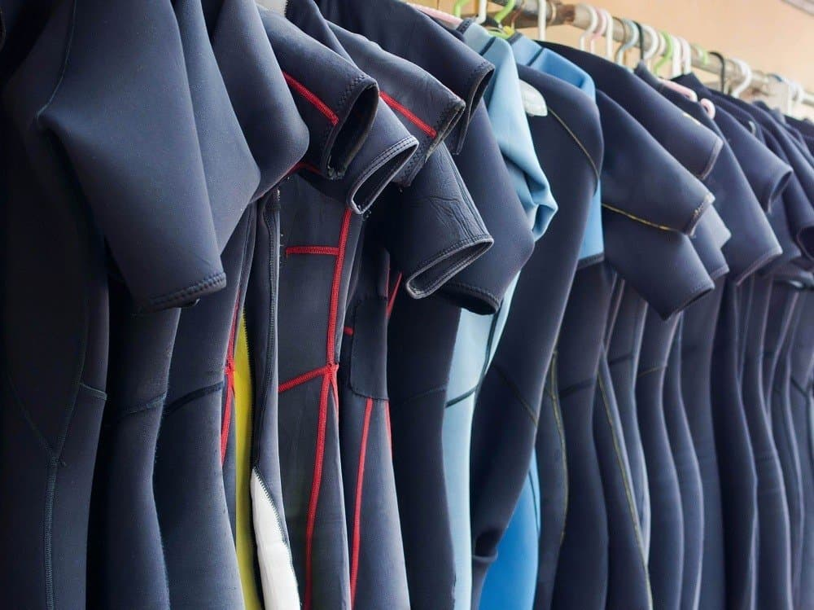
Choose a wetsuit that is closed all around your body, but not too tight - R.M. Nunes

Do I Need To Bring a Knife for Snorkeling
Some snorkelers bring dives on their trips. Largely, these are unnecessary, as entanglement is typically not a big risk during snorkeling.
If you are going to areas where sea kelp or old fishing nets can pose a risk, a knife can be a good idea, though.
Choose a small one that can be attached on your lower leg.
Knife Review: The Halcyon Titanium Knife

Your Snorkel Equipment Setup?
What equipment do you bring on a snorkeling trip and what do you choose to rent? Have you ever had a bad snorkel equipment experience? Bad rental gear etc.? We’d love to hear your snorkel gear stories right here.

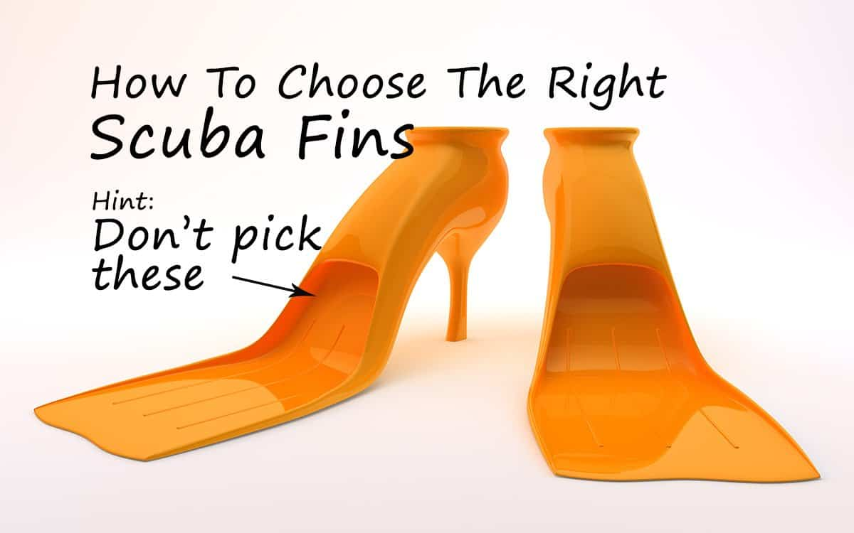

A Basic Guide To Choosing Scuba Fins
by Scuba Expert Staff | 3 comments
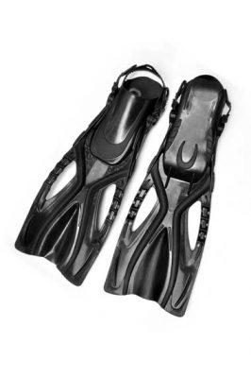
- Parinya Keawkum

Scuba fins are one of the most important scuba investments you will make.
There are many options and it’s all down to personal preference. What is your swimming style? Do you want power or economy of effort?
Will you be mostly shore or boat diving? Will you be travelling with them often?
Let’s look at what to think about when choosing your fins.
Here's our article about Dive Gear: When To Buy What.

Foot vs. open heel
Full foot fins fit like a shoe. They are great if you’re looking for something for dive travel and are not shore diving. They are lighter than pocket fins and do not require booties so the energy needed to swim is reduced.
Open heel fins work with a range of foot sizes but require a bootie to be worn.
I prefer open heel fins for shore diving because you can walk out with your booties and put the fins on later. Personally I find they are more comfortable if you are spending a lot of time in the water.
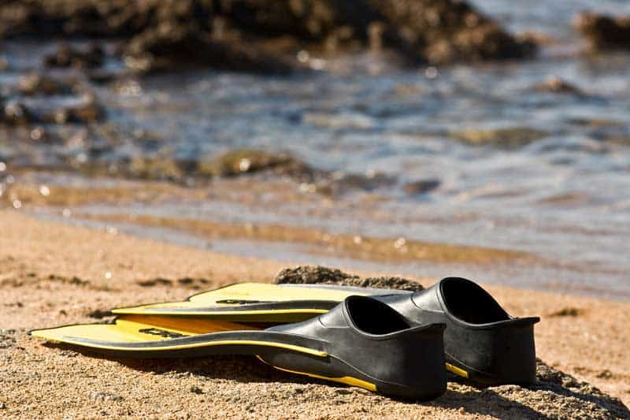
Full foot scuba fins - Credit: EmiDelliZuani

Buckles vs. straps
There are a few different ways open heel fins can be attached to your feet. A basic buckle lets you adjust fin tension once your foot is inside. I am not a fan of these as I find they can start to loosen after a while.
Some types of buckles have a quick release so you can adjust the fit once and then never have to change it. These are easier to put on while in the water than most full foot or basic strap fins.
Here's more on Finning Techniques – How To Get The Most Propulsion From Your Kick.
I Love my spring kit system which entirely replaces the buckle and straps originally supplied with my fins. Spring tension cannot be adjusted, so I took my fins and booties into the shop and tried several sets before I found the right size.
Now I can put my fins on in seconds and they remain comfortable and secure for my entire dive.
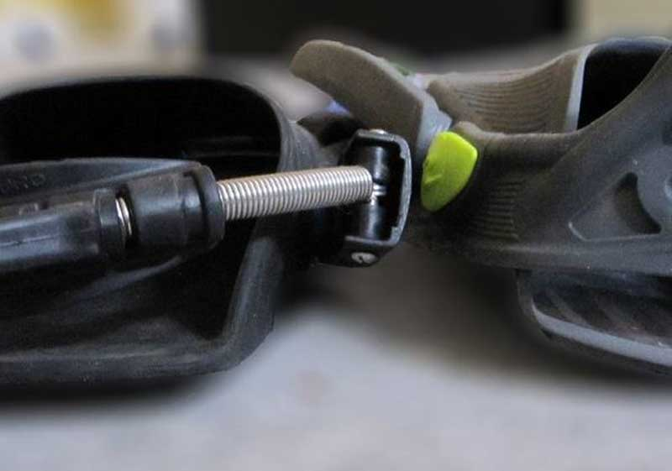
Fin straps closed - Credit: Torben Lonne

Blade Style
Now what about blade style? There are a lot of options, the most common of which I’ve tried to group into categories. The best one for use depends on where you want to use it, its weight, and your swimming style.
Standard paddle fin
Your basic flat surface fin, usually with some reinforcement on the sides to keep water on the fin and provide greater strength.
Channel or Jet fins
Channel fins have different designs designed to contain water efficiently and releasing it as a focused ‘jet’. They are more popular with professional and technical divers than with novices. They tend to be heavy, which can help maintain balance if you are kneeling to teach, but makes them less convenient to travel with.
Here's an Equipment Review on Turtle Fins.
They work well with various swimming styles, but I find they are the best for power when using frog kicks.
Split
Split fins are inspired by fish fins, split up the middle to reduce drag. They provide better propulsion than a single blade fin with less effort. Some people find them too floppy, but it all depends on how you swim with them.
I get the most speed when using long vertical kicks. When I am guiding I can also use an unconventional horizontal side-to-side style to move slowly while not disturbing sand or silt.
In case you disturb sand and silt, Here's How To Survive A Silt-Out.
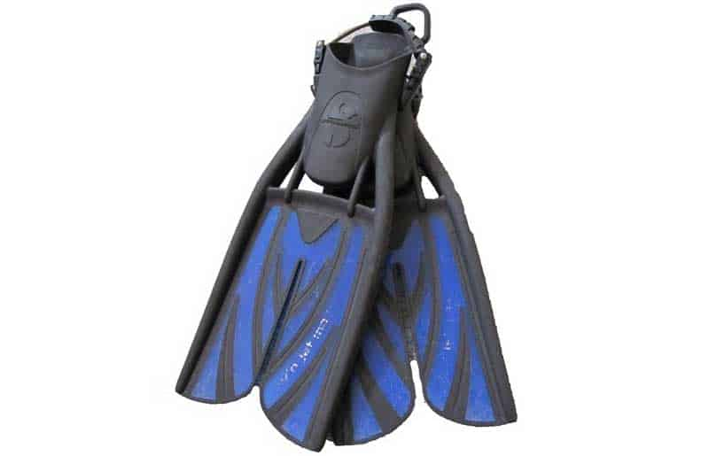
Split type scuba fins inspired by fish fins - Credit: Torben Lonne
Force Fins
Look a bit like a whale tail, and are supposed to provide the best power. They are light and efficient and cost an arm and a leg. Swim with a short flutter stroke for best effect.
Hinged Fins
Hinged fins have a pivot point where the foot meets the blade allowing the angle to be adjusted according to your needs. They are also useful for shore diving as the fin can be worn with the blade lifted out of the way allowing you to walk more easily.

Final Thoughts
I believe that good, comfortable fins are second only to a comfortable mask when diving. They are one of the most important equipment purchases you will make.
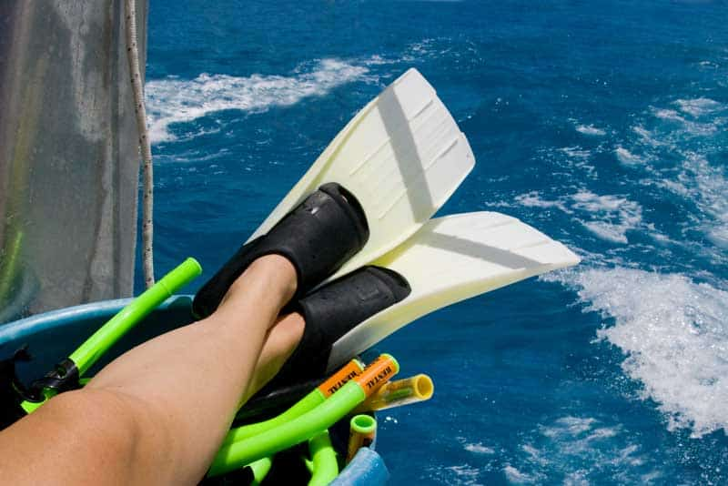
Rented scuba fins are best for trying out - Credit: Oculo
I always recommend renting or borrowing several different kinds of dive equipmentand trying it out before purchase.
Finally, always try new fins on before getting into the water and kick your foot a bit to make sure it stays on!

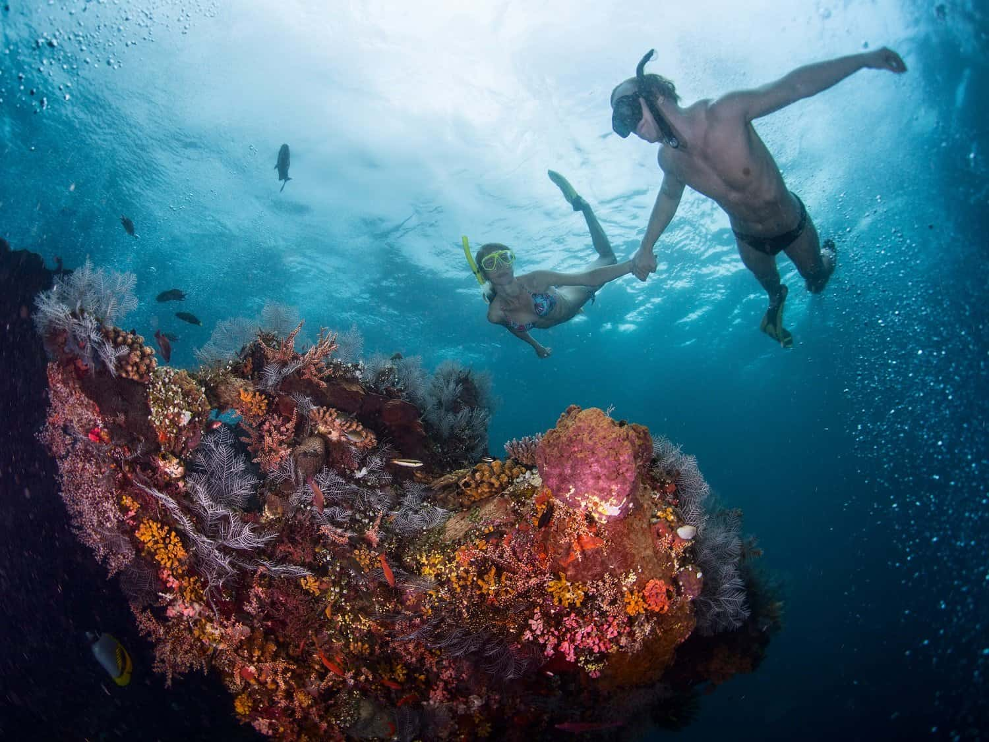

Snorkeling Skills: The Complete Guide To Snorkeling (Part III)
by Thomas Grønfeldt Senger | 0 comments
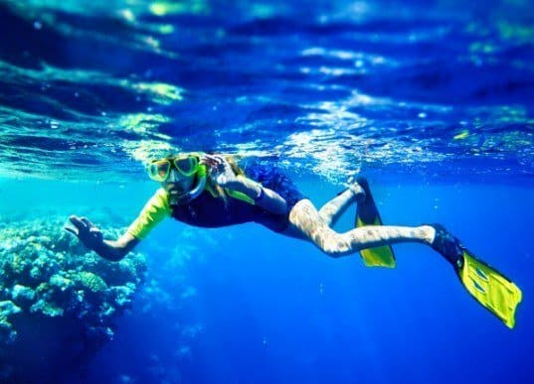
Get your Snorkeling Skills in order - Poznyakov

Get your Flippers and Mask on with our guide to getting the most from your snorkeling
This last article of our guide to snorkeling, we’ll cover in-water techniques to get the most of your snorkeling trips.
You'll learn everything from not overexerting yourself, to extending your time on breath-hold dives, these tricks will help you become a better snorkeler.
You’re finally here, ready to jump (or wade) into the water and start your snorkeling trip on your holiday.
You’ve done your preparations, as per our first part of the snorkeling guide and you’ve selected the best possible snorkeling equipment for you (whether you rent or purchase it), again as per our second part of the snorkeling guide. And now it’s time to do what this is all about, experience the undersea world.
But your snorkel trip won’t come to much if you run out of energy after the first 10 minutes.
Snorkeling in the tropics, you still need to know what you are doing - Martin Valigursky

Conserving Energy While Snorkeling
Going for a leisurely swim in tropical waters may not sound like serious exercise, but make no mistake, snorkeling can take it out of you! Even in very warm water, your body loses heat continuously, due to water’s heat capacity being greater than air’s.
And propelling yourself forward with fins on requires some energy as well.
Learn The Differences Between Snorkeling, Free and Skin Diving
Add to this that snorkeling trips can be all-day things, with hours spent in the water, and you can see why thinking about keeping your energy expenditure down is useful!
As with scuba diving, the first rule is to slow down, relax, and let your fins do the work for you.
Being in water is a new experience for most, so taking the time to relax your body and mind is a big first step.
Many new snorkelers have a tendency to try and swim along using their arms, like they’d do in a pool. But our legs, in particular with fins on, outperform our arms many times over. So a good way to conserve energy is to keep our arms relaxed at our sides and focus on our fins instead.
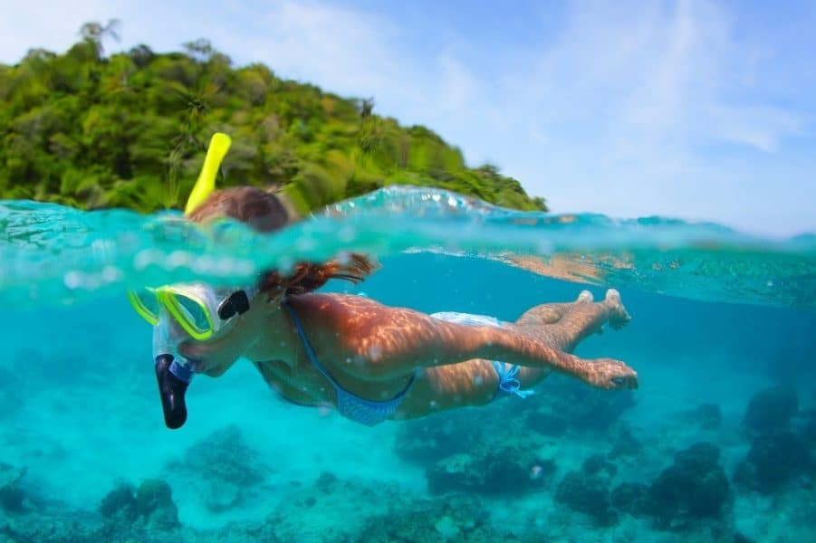
Remember to Relax in the water. Take your time and enjoy the show! - Credit: Dudarev Mikhail
And don’t kick too hard, even a leisurely kicking pace is enough to drive you forward, and moving too fast just means you’ll zoom by interesting sights.
Plus, kicking too hard and flailing with your arms creates a lot of splashing that will scare away the very animals you’re there to see!
Learn The Finning Techniques used for Scuba Diving

Conserving your air while snorkeling
Breath deep and slow. Breathing through a snorkel can be quite different from breathing without one.
Taking deep breaths is important to get the most out of it. Taking deep breaths also helps keep your heart rate down, which in turn helps you relax and conserve energy.
Read the Full Skin and Breath hold Free Diving Guide

Snorkeling deep
Many snorkelers are completely happy staying in the surface throughout their dive, and in that case, they should.
Sometimes going down is great - FAUP
While others feel the urge to take short dives on a breath-hold to get closer to reefs, marine animals, or other features in the deep. To get the most out of your single breath, there are a few things you can do:
First foremost, relax.
Take a few moments in the surface to move as little as possible and get your breathing under control.
Then, take a few deep, controlled breaths.
Don’t hyperventilate! This was taught on scuba courses years ago, but has since been proven to be counterproductive. Simply breathe deep and slowly to fully fill and empty your lungs. Then, take an extra deep breath, making sure to fill up your diaphragm first, then chest, and finally the very top of your torso.
When you’re ready for your descent bent 90 degrees at the waist so your torso is submerged and vertical in the water, and raise your leg up so they, too, are vertical but above water.
The weight of your legs will drive you into the depths, saving you energy in the process. As your fins reach the water, use them to gain further depth.
This is much, much more efficient than the swimming ascent you often see inexperienced snorkelers attempt.
Once your underwater, relax.
Most people can significantly improve their breath holds simply by slowing down and relaxing. Swim slowly and efficiently, seeking to streamline your body and making every movement about propelling you forward.
Err on the side of conservatism. Come up well before you run out of air, and slowly extend your bottom time for each time you dive. Soon, you’ll get a feel for how long you can stay down safely, and most likely, it will be considerably longer than your first venture under the surface.
Read: What To Look For When Buying a Mask
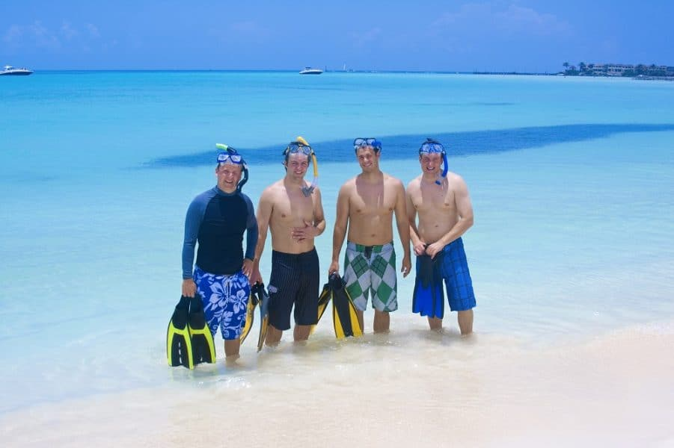
Now it's time to go snorkeling - Credit: Brocreative

https://www.divein.com/snorkeling/snorkeling-skills-complete-guide-snorkeling/

